Task 1
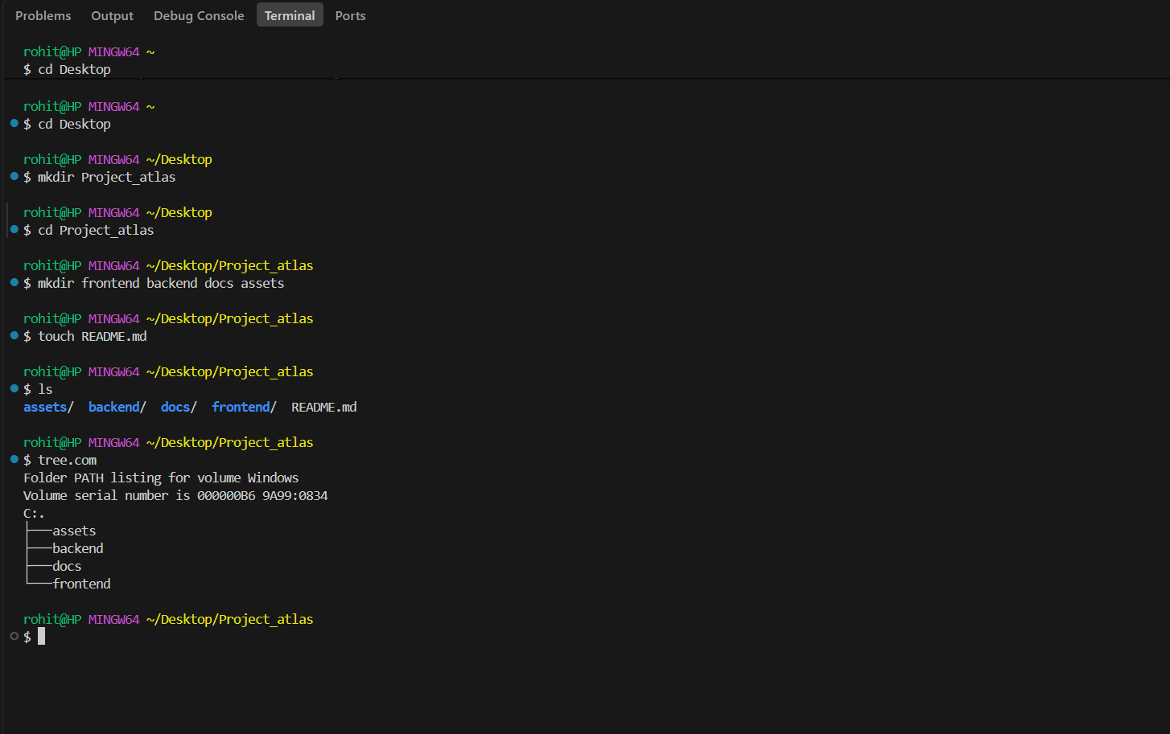
- These folders are used to organize our project which makes easier to connect to frontend and backend
Task 2
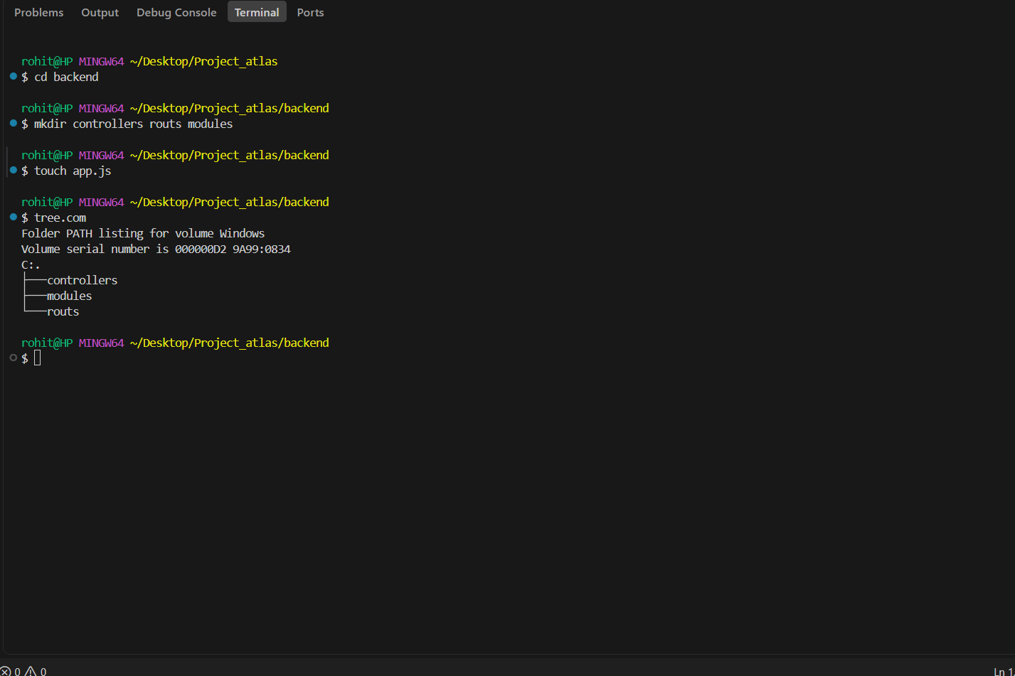
App.js is entry point of application,models for usename password,
Route defines API and controllers contain core logic for processing requests

Task 3
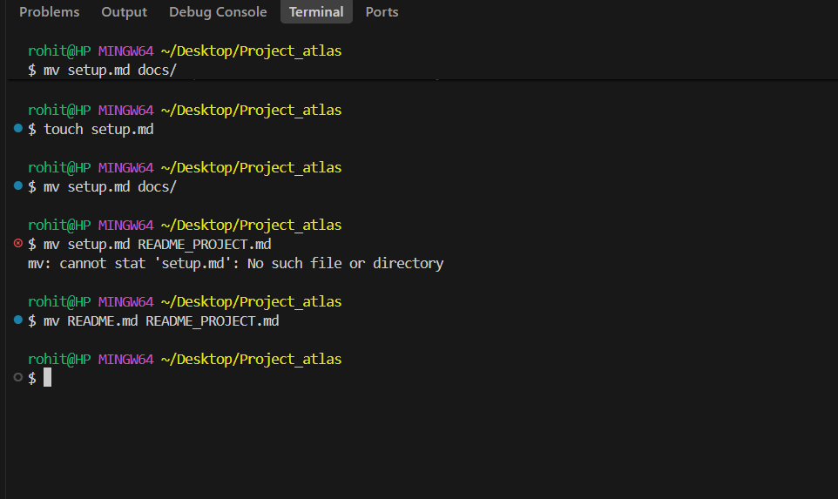

Task 4
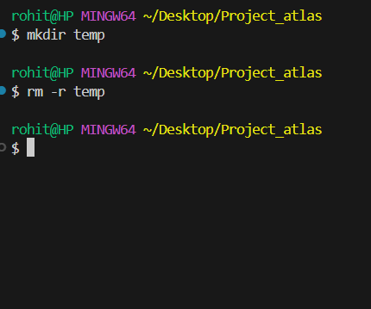

Task 5
